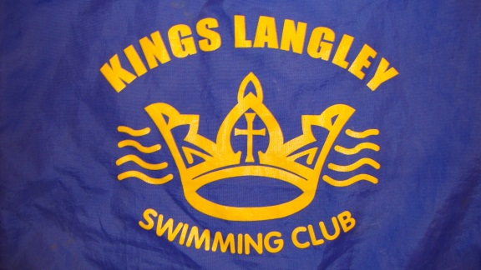**BASED AT KINGS LANGLEY SECONDARY SCHOOL AND YORK HOUSE SCHOOL POOLS**

**www.KingsLangleySwimmingClub.co.uk**

**HAVE YOUR CHILDREN HAD**

**SWIMMING LESSONS BUT YOU**

**DON’T KNOW WHAT TO TRY NEXT?**

**WHY NOT JOIN THEM UP TO**

**KINGS LANGLEY SWIMMING CLUB?**

We are a friendly, informal club who are based at Kings Langley Secondary School Pool and always welcome new members. If your child is confident to swim lengths but would like to improve their strokes, fitness, stamina and have some fun, we would welcome them for a trial. We hold competitions during the year both in-club and against other teams in the local area.

Our club fees which are up to 50% less than other clubs in the area will enable your child to swim up to three times a week though we don’t mind if it’s less! We are particularly looking for boys aged 9 – 16 for our race team but welcome anyone from 9 years and above. Adult swimmers are also welcome if you would like something more challenging than plodding up and down a lane in a public session!

Please call Carol Preston on 01923 269805 or Lesley Foster on 01923 262217 for a chat or simply turn up at Kings Langley Secondary School pool at 6pm on a Wednesday or Thursday in school term time for a trial.